

**EEE1024: Fundamentals of Electrical and Electronics Engineering**

**Dr. Sanchit Khatavkar**

*v*(*t*)  *Vm* sin(*t* ** )

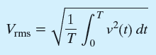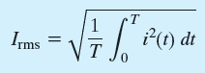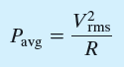

*V*

*rms*

 *Vm*

2

*Irms* 

*I*

*m*

2

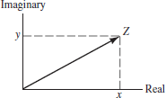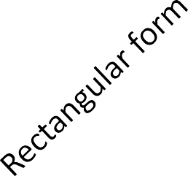*z*  *x*  *iy z*  *x*  *iy*

## Complex conjugate

Real Imaginary

*Z***

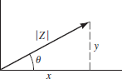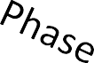

 *Z* (cos**



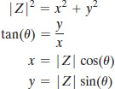 *i* sin** )



 1

 

## PHASORS

Voltages and Currents

As vectors in complex plane

VOLTAGES VOLTAGE PHASORS



Definition of phasor –

Real part of complex numbers, in polar form



…………………………………………………

sin(** )  cos(**

− 90*o* )

## CURRENTS CURRENT PHASORS







STEP 1:

Convert all voltages into cosine function – use trigonometry

sin(** )  cos(**

− 90*o* )





STEP 2:

Write PHASORS for each voltage (or current)



STEP 3:

Convert PHASORS into complex numbers - rectangular form

# *v*(*t*)  10(cos0  *i* sin 0)  5(cos(30)  *i* sin(30))  5(cos(90)  *i* sin(90))

 10(1 0)  5(0.866  *i*(0.5))  5(0  *i*(1))

 10  5*0.866  *i*(2.5)  5*i*

*v*(*t*)  14.33  *i* * 2.5



STEP 3:

Convert PHASORS into rectangular form of complex numbers.



# *v*(*t*)  14.33  *i* * 2.5



STEP 4:

Convert from rectangular form back to PHASORS (form)



*Z***

## We need,

14.332  2.52

*Z* ,**

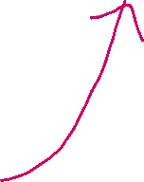

STEP 5:

*v*(*t*) 

# *v*(*t*)  14.549.89

tan1 (2.514.33)

Convert PHASORS back into sinusoidal form



# *v*(*t*)  14.54 cos(*t*  9.89)

## Q1)

Q2) 

Q3)





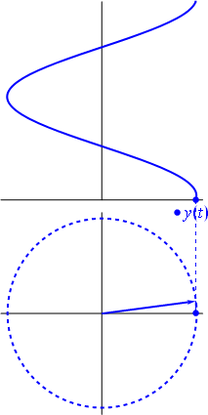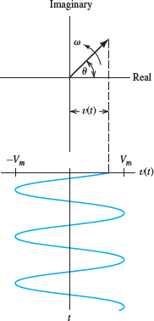PHASORS rotate Counter-clockwise!

PHASORS rotate Counter-clockwise!





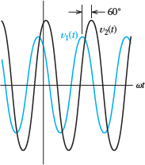

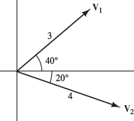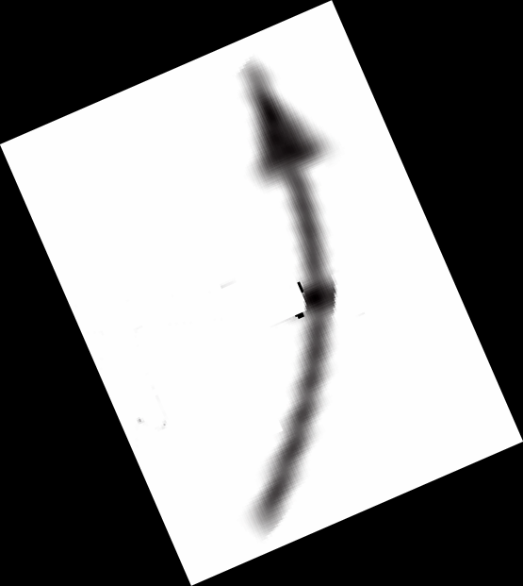

3 voltages are given as -

*v* (*t*)  cos(*t*  30*o* )

1

*v* (*t*)  cos(*t*  30*o* )

1

*v* (*t*)  cos(*t*  45*o* )

1

## State the phase relationship between each pair of voltages



Acknowledgements

1. Allan R. Hambley, ‘Electrical Engineering - Principles & Applications, Pearson Education, First Impression, 6/e, 2013
2. <https://en.wikipedia.org/wiki/Phasor>